 

### Bachelor of Technology in

**COMPUTER SCIENCE AND ENGINEERING**

**22AM2403 – DATABASE MANAGEMENT SYSTEMS**

**MINI PROJECT REPORT**

On

### FORENSIC EVIDENCE MANAGEMENT SYSTEM

Submitted By

## G Hasini Chowdary (ENG22AM0176)

## Kushal J R (ENG22AM0178)

## Vaishnavi (ENG22AM0198)

## Vikas S (ENG22AM0200)

### UNDER THE SUPERVISION

### Prof. SRIRAMKUMAR R

Asst. Professor, CSE (AI & ML), DSU

**DEPARTMENT OF COMPUTER SCIENCE & ENGINEERING**

**SCHOOL OF ENGINEERING DAYANANDA SAGAR UNIVERSITY**

### (2023-2024)



**School of Engineering**

**Department of Computer Science & Engineering**

Harihalli, Ramanagara - 562112

Karnataka, India

**CERTIFICATE**

This is to certify that the DBMS MINI PROJECT titled “**Forensic evidence management system**” carried out by **G.Hasini Chowdary (ENG22AM0176), Kushal J R(ENG22AM0178), Vaishnavi (ENG22AM0198), Vikas S (ENG22AM0200)** bonafide students of Bachelor of Technology in Computer Science and Engineering at the School of Engineering, Dayananda Sagar University, Bangalore in partial fulfillment for the award of degree in Bachelor of Technology in Computer Science and Engineering, during the year 2023-2024.

|  |  |  |
| --- | --- | --- |
| **Prof. Sriram Kumar** | **Dr. Jayavindra Vrindavanam** | **Dr. Uday Kumar Reddy K R** |
| Asst. Professor,  Dept. of CSE(AI & ML)  School of Engineering Dayananda Sagar University | Chairman, CSE (AI & ML)School of Engineering Dayananda Sagar University | Dean  School of Engineering Dayananda Sagar University |

**DATE:**27-05-2024

# **ACKNOWLEDGEMENT**

It is a great pleasure for us to acknowledge the assistance and support of many individuals who have been responsible for the successful completion of this DBMS MINI PROJECT

First, we take this opportunity to express our sincere gratitude to the School of Engineering & Technology, Dayananda Sagar University for providing us with a great opportunity to pursue our bachelor’s degree in this institution.

We would like to thank **Dr. Uday Kumar Reddy K R, Dean**, **School of Engineering & Technology**, **Dayananda Sagar University For** his constant encouragement and expert advice. It is immense pleasure to express our sincere thanks to **Dr. Jayavrinda Vrindavanam, Chairman**, **Department of Computer Science (Artificial Intelligence and Machine Learning), and Engineering**, **Dayananda Sagar University,** for providing the right academic guidance that made our task possible.

We would like to thank our teacher **Prof. R. Sriram Kumar, Asst. Professor,** **Department of Computer Science and Engineering (Artificial Intelligence and Machine Learning),** **Dayananda Sagar University**, for sparing his valuable time to extend help in every step of our DBMS MINI PROJECT, which paved the way for smooth progress and the fruitful culmination of the project.

We are also grateful to our family and friends who provided us with every requirement throughout the course. We would like to thank one and all who directly or indirectly helped us in the DBMS MINI PROJECT.

# **ABSTRACT**

Forensic evidence management and integrity are critical to achieving fair results in the field of criminal investigations. The goal of this project is to use a database management system (DBMS) to build and deploy a complete forensic evidence management system (FEMS). The principal aim is to optimize the procedures of gathering, organizing, evaluating, conserving forensic evidence while enforcing strict security measures to avert manipulation and unapproved entry. It is a comprehensive solution designed to address the challenges faced by law enforcement and forensic agencies in managing and analyzing vast amounts of evidence.   
A centralized database that enables effective data entry and retrieval will

be a component of the proposed FEMS. It will support a variety of forensic evidence kinds, including digital, physical, chemical, and biological

objects. To improve operational efficiency and accountability, advanced features including evidence barcoding, automatic reporting, and chain-of-custody tracking are included. It also offers a more dependable, effective, and safe way to handle forensic evidence. Enhancing the precision and

swiftness of forensic examinations while preserving the authenticity of the proof, FEDMS is vital in bolstering the legal system and preserving the

rule of law.

Evidence tracking and cataloging, data integration and analysis, automated workflows, secure access and permissions, and extensive reporting and visualization capabilities are some of the FEDMS's primary features.

## TABLE OF CONTENTS

**PAGE NO**

ABSTRACT

CHAPTER 1 INTRODUCTION 6

CHAPTER 2 PROBLEM STATEMENT 7

CHAPTER 3 PROJECT DESCRIPTION 8

CHAPTER 4 DESIGN 9

CHAPTER 5 METHODOLOGY 10

CHAPTER 6 TESTING AND RESULT 11

CHAPTER 7 SYSTEM IMPLEMENTATION 13

CHAPTER 8 CONCLUSION 15

CHAPTER 9 REFERENCES 16

# **INTRODUCTION**

The Forensic Evidence Management System (FEMS) is a sophisticated database management project designed to enhance the efficiency, accuracy, and reliability of managing forensic evidence in criminal investigations. This system addresses the critical need for secure, organized, and accessible evidence handling procedures, ensuring that every piece of evidence is meticulously tracked from collection to courtroom presentation.

FEMS ensures that forensic evidence is accurately recorded, securely stored, and easily accessible to authorized personnel.

Conventional approaches to forensic evidence management, which frequently rely on manual procedures and paper-based records, are vulnerable to mistakes, mishandling, and possible manipulation. An advanced and secure system to manage forensic data is becoming more and more necessary as its volume and complexity rise. The FEDMS is designed to address the growing need for a comprehensive and reliable evidence management system that can keep pace with the ever-evolving technological landscape.

This project proposes the development of a Forensic Evidence Management System (FEMS) leveraging the capabilities of a Database Management System (DBMS). The objective is to create an integrated platform that facilitates the seamless collection, storage, analysis, and retrieval of forensic evidence. By harnessing advanced database technologies, the system aims to enhance the accuracy, efficiency, and security of forensic evidence management.

# **PROBLEM STATEMENT**

In the complex and dynamic field of criminal investigations, as the volume and complexity of evidence data continue to grow, law enforcement and forensic agencies face significant challenges in efficiently cataloging, storing, and analyzing this crucial information.

The major issues of the current condition of forensic evidence management are Fragmented Data Storage, Lack of Standardized Processes, Inefficient Workflow Automation, Limited Analytical Capabilities, Compromised Evidence Integrity, Difficulty in Sharing and Collaboration. All of these issues impact the efficacy, dependability, and efficiency of forensic investigations, which can result in hampered evidence, postponed case resolutions, and sometimes unfair results.

SOLUTION-A thorough Forensic Evidence Database Management System (FEDMS) that can consolidate and streamline the whole evidence management lifecycle, from collection to court presentation, is desperately needed to address these issues. A system like this needs to make use of automation, sophisticated data management strategies, and analytical skills to improve the effectiveness, dependability, and security of forensic investigations.   
  
Law enforcement and forensic organizations can fully utilize the potential of their evidence data by putting in place a strong FEDMS. This will improve case results, boost public confidence, and improve the functioning of the criminal justice system.

**PROBLEM DESCRIPTION**

The FEDMS will be built upon a custom-designed database schema, which will be represented in an Entity-Relationship (ER) diagram. The ER diagram will illustrate the various entities, their attributes, and the relationships between them, ensuring the efficient storage and retrieval of forensic evidence data.

A number of crucial features and capabilities will be incorporated into the Forensic Evidence Database Management System in order to solve the issues found and accomplish the project's goals:

**Centralized Evidence Cataloging and Tracking**: This all-inclusive evidence management module keeps track of the flow of both digital and tangible investigated.   
**Automated Workflows**: These reduced human labor and increased overall efficiency by streamlining common procedures including evidence submission, laboratory requisitions, and report preparation.   
**Secure Access Controls**: To guarantee the integrity and confidentiality of the stored evidence data, strong user authentication, role-based permissions, and audit logging are used.   
**Data Integration and Analysis**: The ability to combine information from various sources, carry out sophisticated analysis, and provide personalized reports to assist with well-informed decision-making.   
**Cooperation and Information Sharing**: Safe sharing methods that facilitate smooth cooperation between forensic labs, law enforcement, and other investigation-related parties.

# Key results from the successful implementation of the Forensic Evidence Database Management System are anticipated to include: increased analytical capabilities and data-driven insights to support case solving and decision making; strengthened collaboration and information sharing among stakeholders leading to more successful case resolutions; and an overall improvement of the criminal justice system through the effective management and utilization of forensic evidence. Improved efficiency and reliability of forensic investigations through streamlined evidence management processes.

# **DESIGN**

# 

Designing an ER diagram for a DBMS project involves several key steps. Determine the primary entities first.Next, provide the connections between these entities. For instance, there can be more than one piece of evidence in a case, but each piece of evidence is only related to one case (a one-to-many configuration).Once the linkages have been established, ascertain the characteristics of every entity. The database in your project for the Forensic Evidence Management System DBMS will be designed according to this ER diagram.

# **METHODOLOGY**

Requirement Gathering- Conduct interviews and meetings with forensic analysts, law enforcement officers, legal experts, and IT personnel to gather detailed requirements.Create a comprehensive document detailing the functional and non-functional requirements of the system.Develop use cases to capture specific scenarios and user interactions with the system.

System Design-Define the overall architecture, including the database, application layers, and network topology. Design the database schema to accommodate various types of forensic evidence, user roles, chain-of-custody logs, and audit trails. Create wireframes and mockups for the user interface, ensuring it is intuitive and user-friendly.

Technology Selection-Choose a suitable DBMS (e.g., MySQL, PostgreSQL) based on scalability, security, and performance requirements.Choose tools and libraries for implementing security features such as encryption and role-based access control (RBAC).

Implementation- Create the database schema and set up the database environment. Develop the core application, integrating user interfaces, business logic, and database interactions.

Testing-Test individual components of the system to ensure they function as expected.Test the interactions between different system components to ensure seamless integration.Conduct security testing to identify and address vulnerabilities.

Deployment- Set up the production servers, ensuring they are secure and optimized for performance.Migrate existing forensic evidence data to the new system, ensuring data integrity and consistency. Deploy the application and database to the production environment.

Maintenance and Support-Regularly update the system to fix bugs, patch security vulnerabilities, and add new features. Continuously monitor system performance and make necessary adjustments to maintain optimal performance.

# **TESTING AND RESULT**

# 

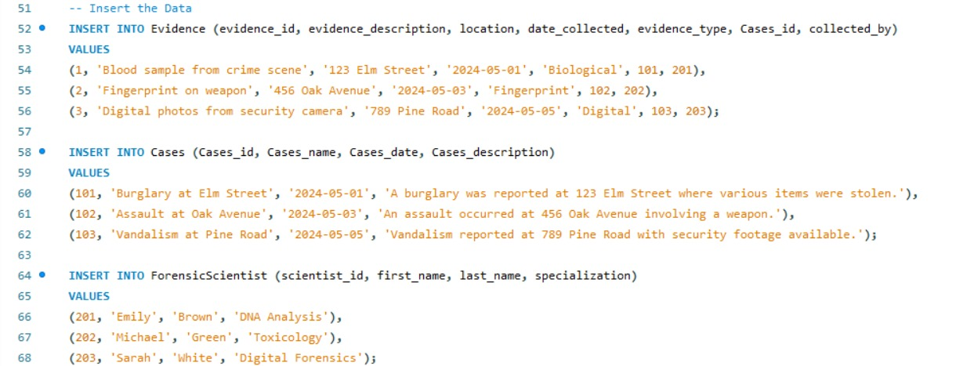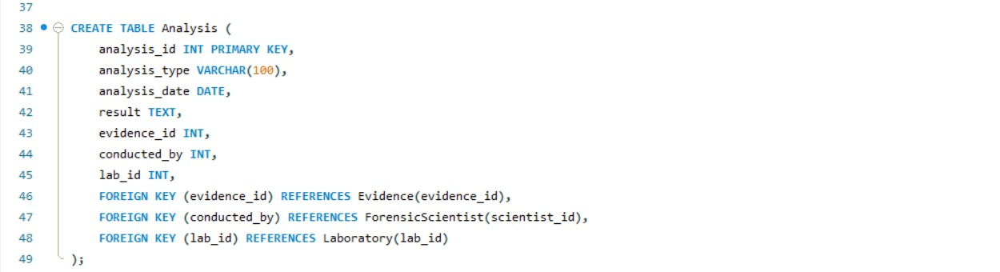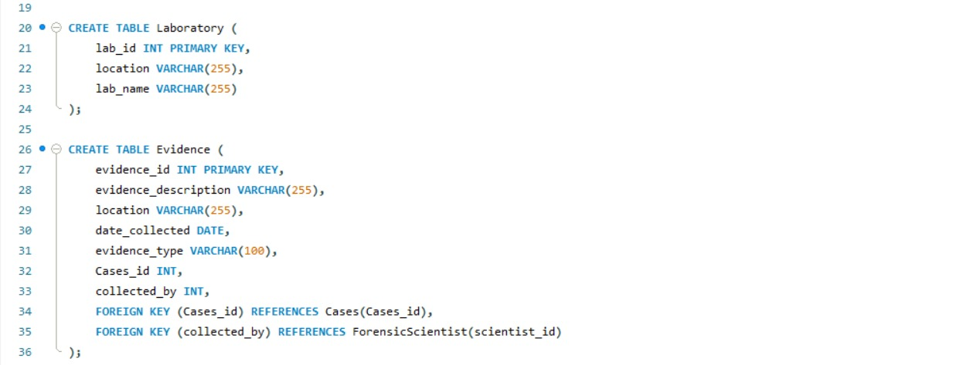

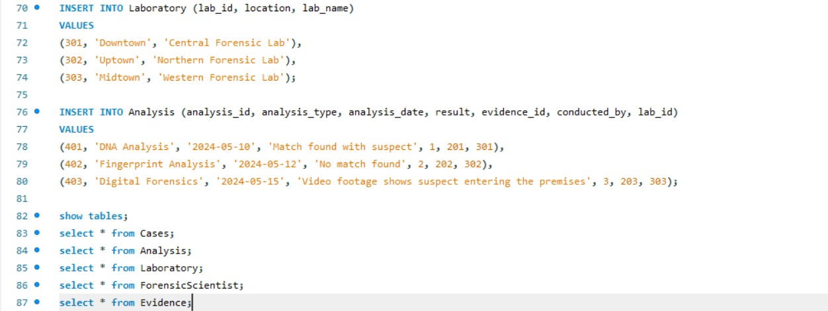

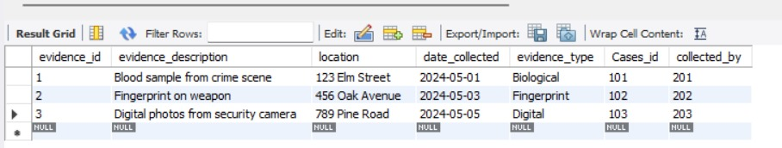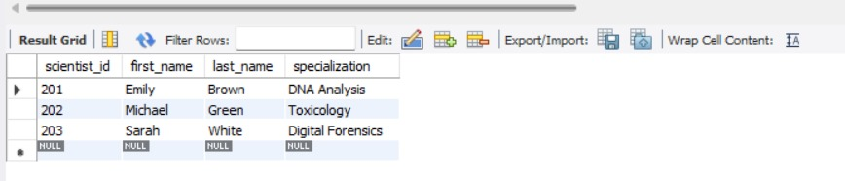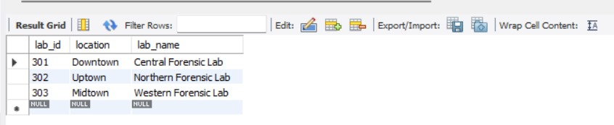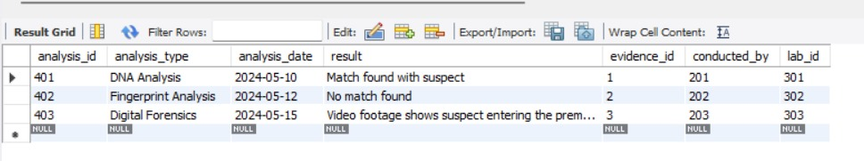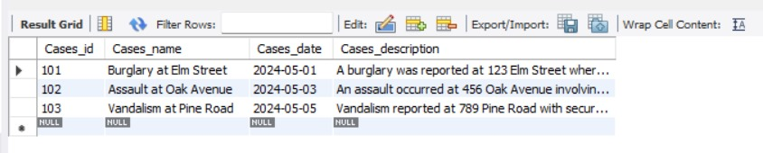

# **SYSTEM IMPLEMENTATION**

# **Count the Number of Evidence Items Collected by Each** PersonSELECT collected_by, COUNT(*) AS evidence_count

# FROM Evidence

# GROUP BY collected_by;

# 

# **Trigger for Insert, Delete and Update**

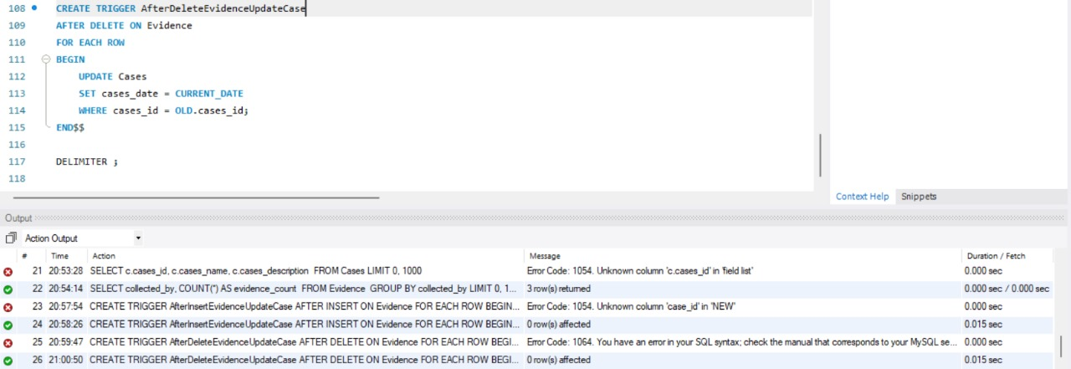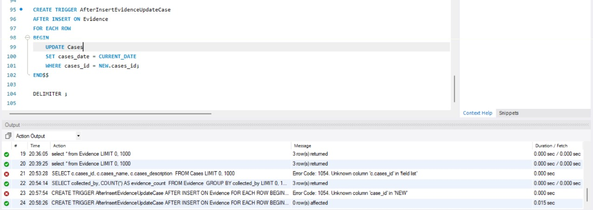

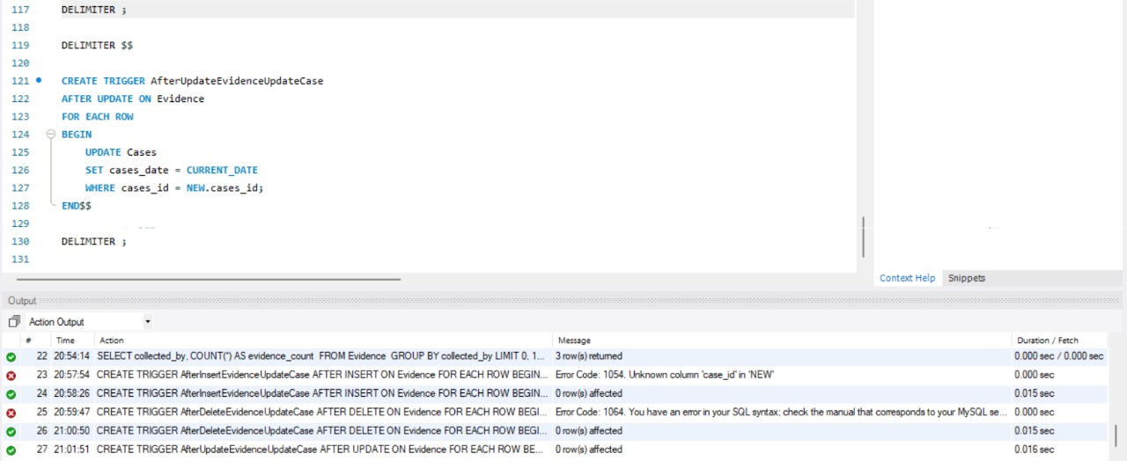

# **CONCLUSION**

# One of the most important steps toward modernizing forensic operations has been the effective installation of the Forensic Evidence Management System employing a DBMS. The technology not only improves the effectiveness and precision of forensic investigations but also fortifies the criminal justice system as a whole by tackling crucial facets of evidence management. Maintaining the FEMS's relevance and efficacy in the dynamic field of forensic science will require constant updates and enhancements as technology advances.

# A significant development in forensic science has been the application of a database management system (DBMS) in the Forensic Evidence Management System. The system improves the precision and dependability of forensic investigations by taking care of important concerns including data management, security, and evidence tracking. This research emphasizes how crucial it is to include technology into forensic procedures in order to efficiently serve the legal system. The FEMS will require constant upgrades and enhancements to be effective and fulfill the changing demands of forensic science as technology advances.

# **REFERENCES**

1.**"Design and Implementation of Forensic Evidence Database Management System" by V. T. Baviskar and S. N. Deshpande**: This paper discusses the design and implementation of a forensic evidence database management system, focusing on data modeling, storage, retrieval, and security considerations.

2**."Forensic Evidence Management: From the Crime Scene to the Courtroom"** by S. Coulson and J. A. Senn: This paper provides an overview of forensic evidence management practices, including the challenges of maintaining chain of custody, data integrity, and accessibility.

3.**International Association for Identification (IAI**): The IAI provides professional development opportunities and resources for forensic science practitioners, including guidelines and best practices for evidence management and database systems.

4. **National Institute of Standards and Technology (NIST)** - Digital Evidence: NIST offers guidance and standards for digital evidence management, which can be applicable to other types of forensic evidence as well.